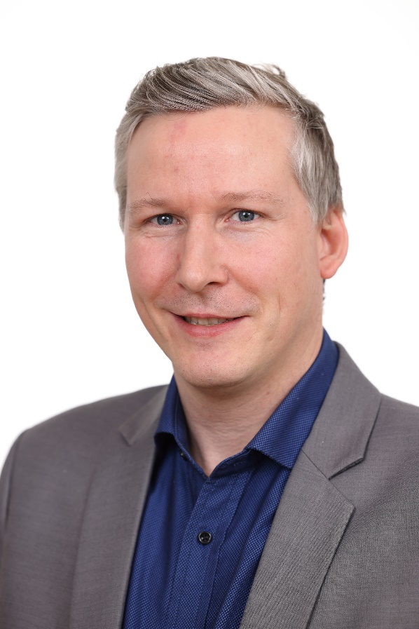
20.11.2023
Florian Herzog, Austrian Chamber of Agriculture
advisory services coordination
Florian Herzog holds bachelor degrees in Environmental System Sciences and in Agrarian Pedagogy and a master's degree in Natural Resources Management & Ecological Engineering. He started his professional career as a research fellow at the University of Natural Resources and Life Sciences Vienna (BOKU). Working in applied research projects in the field of entrepreneurship and innovation capacity building among rural communities formed the basis for his keen interest in the drivers of transformational change and rural development.
For now more than a decade Florian Herzog is working as advisory services coordinator at the Austrian chamber of agriculture, currently as head of the unit ‘knowledge transfer & innovation’. Applying his expertise in methods and instruments of knowledge transfer and promoting interactive innovation, his current focus of interest lies on farm business management, digitization of agriculture and agricultural knowledge and innovation systems. Florian is representing the Austrian advisory services in several working groups and bodies on EU-level, is an active member of the advisory networks (IALB, EUFRAS and GFRAS) and is actively involved in several AKIS-related projects on national and European level, such as modernAKIS, EU-Farmbook, ATTRACTISS.

Florian Herzog, Avstrijska kmetijska zbornica usklajevanje svetovalnih storitev
Florian Herzog je diplomiral iz znanosti o okoljskih sistemih in agrarne pedagogike ter magistriral iz upravljanja naravnih virov in ekološkega inženirstva. Svojo poklicno pot je začel kot raziskovalec na Univerzi za naravne vire in znanosti o življenju na Dunaju (BOKU). Delo pri aplikativnih raziskovalnih projektih na področju podjetništva in krepitve inovacijskih zmogljivosti podeželskih skupnosti je bilo podlaga za njegovo veliko zanimanje za dejavnike transformacijskih sprememb in razvoja podeželja.
Florian Herzog že več kot desetletje dela kot koordinator svetovalnih služb na avstrijski kmetijski zbornici, trenutno kot vodja enote "prenos znanja in inovacije". Svoje strokovno znanje uporablja na področju metod in instrumentov prenosa znanja ter spodbujanja interaktivnih inovacij, trenutno pa se osredotoča na upravljanje kmetijskih podjetij, digitalizacijo kmetijstva ter sisteme znanja in inovacij v kmetijstvu. Florian zastopa avstrijske svetovalne službe v več delovnih skupinah in organih na ravni EU, je aktiven član svetovalnih mrež (IALB, EUFRAS in GFRAS) ter dejavno sodeluje v več projektih, povezanih z AKIS, na nacionalni in evropski ravni, kot so modernAKIS, EU-Farmbook, ATTRACTISS

Florian Herzog

